Domayne’s Royal Bed

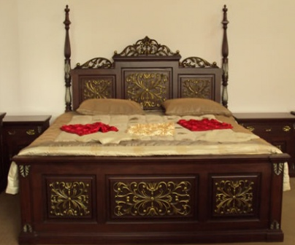

|  |
| --- |
| **DESCRIPTION** |
| Domayne introduces wooden bed which redefines the power of wood. This bed is guaranteed to create the perfect look in any house. The rich wood makes you feel very important it gives you royalty at affordable rates. Perfect for any room of the house, your guests will love this comfortable mood lifting bed. |

|  |  |  |
| --- | --- | --- |
| **Price** | **1400$** | |
| **Dimensions** | **H** x **W** x **L** | **35in x 60in x 80in** |
| **Features** | **Wood claims to be perfectly mature to give you a perfect relaxation time makes you feel important** | |
| **Finished** | **Soft brown form** | |
| **Available in** | **Brown,golden** | |